Project Report: Innovative approaches to hands-on learning and skills development for students from a ‘widening participation’ background
Authors: Joanne Tippett, SEED, The University of Manchester, joanne.tippett@manchester.ac.uk
Fraser How, Ketso Ltd., fraser@ketso.com

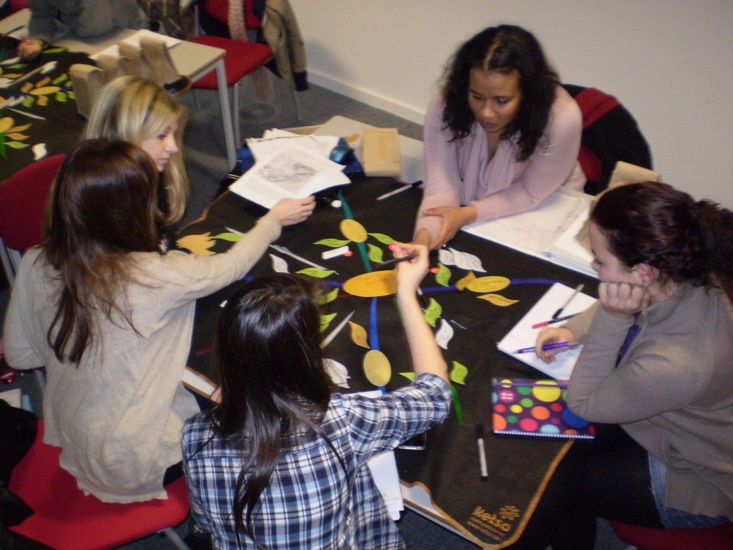

Contents
Background and Introduction 2
Summary of analysis by project strands 3
Cross-cutting benefits 3
Employability 4
Widening Participation 5
Disability Support 6
Ketso training for University of Manchester staff and researchers 7
Feedback from students at The University of Manchester who attended workshops using Ketso 9
Comments relating to the overall evaluation of experience 12
Conclusions and next steps 15

Background and Introduction
As part of its commitment to enhancing the student experience and supporting students from non-traditional backgrounds to attend university, the Directorate of Student Experience funded a two-semester long project to develop, trial and assess a series of interventions to enhance engagement with Widening Participation (WP) students. This used Ketso, an innovative, University of Manchester developed, toolkit for hands-on engagement. The aim was to see if the trials showed evidence of increased engagement, developing and recognising transferable skills, in which case use of Ketso in a range of ways could be written into the offer of support for Widening Participation students at The University of Manchester.
The project offered an innovative collaboration between Professional Support Staff, academics and a spin-off social business (Ketso), and as such exemplifies the University's approach to 'Creating an Excellent Student Experience Through Partnership'.
A total of 291 students attended 12 workshops using Ketso as part of this project, with one workshop run by a Graduate Teaching Assistant (IDPM), one by an academic (Law), and one by a researcher working with the Learning Commons. In addition, 107 staff and researchers attended training in using Ketso offered as part of the project.
This report offers an interim analysis of data from the workshops in semester 1, (during which Dr. Tippett was seconded to work on the project for two days a week). It will be used to provide an opportunity for participants in the project to comment on the emerging themes and analysis. This will feed into a fuller report, which will incorporate further data gathered in semester two, as well as analysis of data gathered from students who used Ketso in their learning at The University of Manchester between 2010 and 2012.
The project has three main strands: employability, widening participation and disability support. The results and feedback to date show that use of Ketso is likely to be beneficial across all of these strands. A brief review of each of these project strands follows below, followed by a closer look at the feedback from staff and student participants in the workshops.

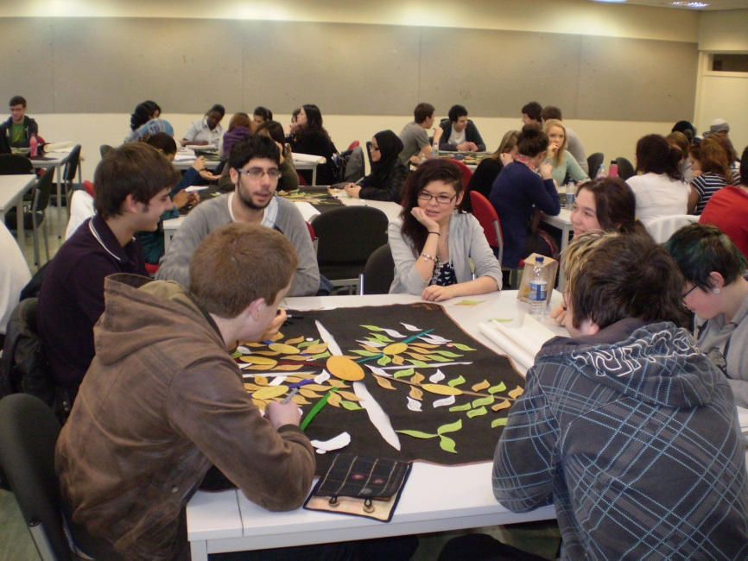

Summary of analysis by project strands

Cross-cutting benefits
The following chart shows answers to the question ‘How did you find the use of Ketso’, which was asked of students on the workshops run as part of this project using Ketso.
Figure 1 Student feedback on use of Ketso (workshops without late starts)

As can be seen, the feedback was overwhelmingly positive. This feedback, as well as more detailed comments and the themes emerging from the workshops, is discussed in more detail below.
Part of the challenge with measuring the value of using Ketso is that the benefits are wide-ranging and cut across different areas. For example, there were many items of feedback that supported the notion that use of Ketso results in ‘Improved Communication’. This would in turn have a beneficial effect in any context, and therefore should be considered as helpful for employability, disability support and widening participation. This is just one example of a broad cross-cutting benefit of using Ketso. Other such benefits that have been identified, and for which there is much supporting evidence in this project, are: Inclusive Participation, Peer Learning, Effective Thinking and More Creativity. These should be considered as evidence for the benefits of Ketso across all three project areas, in addition to the particular evidence presented under the project headings below.
In particular, the high number of comments from students around the inclusive nature of Ketso gives an indication that it is valuable in supporting students from non-traditional backgrounds and those who may otherwise have difficulty feeling included in group discussions, such as those with unseen disabilities. Comments from students included:
- It facilitated people finding answers to their own questions despite not believing they had the answer
- Extremely balanced discussion
- I think that Ketso maximises the chance or likelihood that ALL participants will be able to input their ideas
- Good way of encouraging everyone to speak and get ideas out there
- It promotes discussion, makes it easy to contribute because when you put down a leaf, other people in the group are interested in what you've written. It's visual
- I liked how it got the whole group involved and allowed us to share our ideas

Employability
The feedback from this project provides strong evidence that Ketso helps to engage and include students, including engagement with employability-related activities. For example, as part of the project, a new workshop focused on ‘Making the most of your university course’ was designed. A total of four of these workshops were trialled with 118 first year students from Geography and Planning during their induction week. These workshops had a strong emphasis on the skills that the students will develop over their time at The University of Manchester. Participants were asked to consider their goals, along with what they came to university for, and to think of their own role as well as the university’s role in helping achieve these goals.
The value of these workshops in terms of helping students to think of their employability and how to enhance it over their time at the university is shown in the following indicative quotes (responses to the question: ‘What did you like about the workshop?’, taken verbatim from the feedback forms):
- Very interactive and makes you think about your own responsibilities.
- How to make the most of our course and what things we should try to achieve whilst we are here
- You can hear what other people are thinking about, and worried about, and they can help with what you are worried about
- I liked the fact that group discussions about the time at the University made a very nice flow of ideas and also cleared my mind about what I can look forward to as my experience at Manchester
- As a group we saw that we have similar ideas and thoughts about careers, on what we have chosen
- Also good to hear about a few other things available to students around the University and good to get to know others on the course
- The use of Ketso was very good, worked as a group to see what our goals and achievements are. And we saw on how we can fulfil our desire, on the career we have chosen
Reports of increased peer learning, effective thinking and more creativity, themes which emerged strongly in the data analysis (shown in more detail below), are particularly related to the development of transferrable skills (and indeed could also be considered as such in themselves) .
Several of the participants in the Ketso training sessions were University of Manchester staff who deliver careers support. They could see the value of using Ketso in their work:
- Very useful for careers sessions in small groups on exploring options or careers or skills planning
- Very applicable helps to develop key transferable skills
- [Next step:] Talking with another career consultant about how it could work in practice in careers service

Widening Participation
There are several aspects to consider regarding widening participation: the experiences and feedback of students involved in Gateway and Manchester Access (MAP) programmes; feedback from school pupils on the Gateway programme who experienced Ketso; general feedback from students in workshops who have been identified as ‘WP’; and perspectives from staff involved in related roles (to be developed in the final report).
Students identified as from a MAP background have been included in the more general WP group for this analysis. To date there has not been an opportunity to work directly with students who are engaged in the delivery of MAP activities.
A training session with 10 Gateways Programme Mentors was delivered as part of the project. Comments from these students in the feedback on the training included:
- Help to make you think about your skills and attributes
- It helped to captivate the group and allow them to more easily interact with one another
- It was very useful and other people identified problems and their solutions that I could relate to but had not considered.
The following graph gives an overview of feedback about the use of Ketso from both Gateways mentors and school pupils with whom they delivered sessions using Ketso.
Figure 2 Student feedback on use of Ketso Gateways Programme (WP)

The number of students finding the use of Ketso to be ‘extremely’ or ‘very’ useful (30) hugely outweighs the 10 who found it ‘somewhat’ useful and the 1 who found it ‘not useful’. Comments from the school pupils, who experienced Ketso in a workshop reviewing what they had learned from the Gateways programme, included:
- It made it easier for us to revise everything that happened in the workshops
- You learn about Universities and the future careers you can get into with different degrees
- It gave me an insight for the future
- There was no stress
- Useful conversation about jobs and money
- I figured out route of decisions
- Gave insightful information in a fun way instead of handing out mind numbing leaflets
- It was easy to use and I learned a lot
- Because it was easy to understand and give me a bigger idea of opportunities
The following chart shows an analysis of the combined student feedback about the use of Ketso from all of the workshops (using a Likert scale). This has been broken down by whether or not the student was known to be from a widening partition background, or was registered as having an unseen disability, or neither.
Figure 3 Student feedback on use of Ketso split by type of respondent (WP / Unseen disability / neither)

The picture that is emerging for students from a widening participation background is that their experience of using Ketso in workshops is somewhat polarised. Whilst many students from a WP background found the tool to be ‘extremely’ or ‘very’ useful (in roughly the same proportions as other students), there was a slightly higher relative proportion of students from a widening participation background that found the process ‘not very’ or ‘not’ useful – suggesting something of a ‘marmite’ tendency, where it was somewhat polarised in terms of perceived usefulness. Nevertheless, it should be noted that there are vastly more reports of ‘Love it’ than ‘Hate it’, to continue with the Marmite metaphor. This is backed up by the positive feedback from the Gateways programme discussed above.

Disability Support
Many of the participants in the training sessions focused on coaching in disability support. Their feedback was substantially positive about the potential for using Ketso in their work. Also, as part of the analysis of feedback from student participants in workshops, students have been tracked regarding unseen disability, to gain insight into how their feedback compares to other students.
Feedback from students registered as having an unseen disability was more positive than students without unseen disabilities, with none reporting their experience of Ketso as ‘not very’ or ‘not’ useful (see Figure 3 above). Comments from the feedback forms from students with unseen disabilities (which included learning disabilities as well as mental health problems) on how they found the use of Ketso included:
- It was good to see what other people’s worries and concerns were, to show I'm not the only one
- Easy to think of your own ideas / suggestions & explain without becoming confused or losing trains of thought.
- Visually easy & logical
- This is a really useful tool, much better than just talking round a table. All mapped out in front of you
- It was good to talk about these ideas with others and in a very structured way
- Was easy / clear to use, made ideas easy to read
- The layout is very easy to understand and follow especially with different colour leaves.
- We were made to think about the knowledge we know without notes
Feedback from Access Summit Coaches who attended training included:
- The Ketso exercise provided visual and evidence based findings which could help to empower a student experiencing low self-esteem or confidence issues. The draft completed Ketso exercise results in a 'physical' representation of the work that the student has undertaken or completed in a study session.
- An energizing and empowering resource to invite or encourage the student to become actively engaged with their study support or learning strategies.
- There are certain coaching instruments that will give more to coaches because of using Ketso
- Ketso could be a very useful tool to identify how the students perceived their difficulties and strategies to overcome these.
In addition, roughly 50 Access Summit Study Coaches worked with Ketso in a short, introductory session (not counted as part of the training sessions) at the beginning of semester one. 112 ideas for using Ketso were developed by these Study Coaches, for example:
- Discussion of reading material
- To help students plan essays - presentations written work at all levels
- Assessing a situation (Stressful / academic)
- Discuss well-being
- Structuring big projects like dissertations
- Creating a plan of action for learning

Ketso training for University of Manchester staff and researchers
As part of this project to embed hands-on engagement across the University, 8 half-day training sessions were offered to staff and students A total of 107 people attended training, including 10 academics, 28 Professional Support Staff and 8 Access Summit Study Coaches.
There were 3 types of workshop: A general introduction to Ketso (3 sessions), Ketso for coaching and mentoring (4 sessions) and Ketso as a research method (run in conjunction with Methods@Manchester) (1 session).
Participants were asked for feedback about the training, as well the likely value of Ketso for their work. The following charts show a summary of the responses (N= 58, return rate 54%).
Figure 4 Feedback on Ketso training
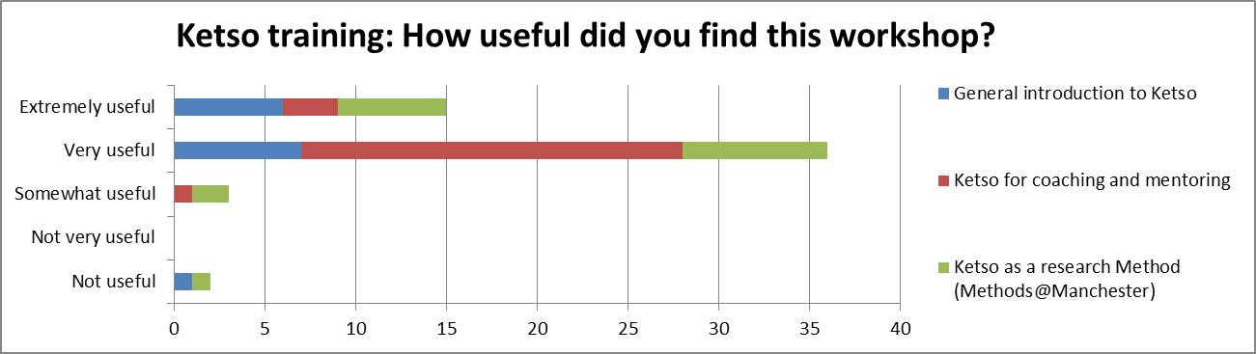
Figure 5 Feedback on how useful participants in training think Ketso could be in their work
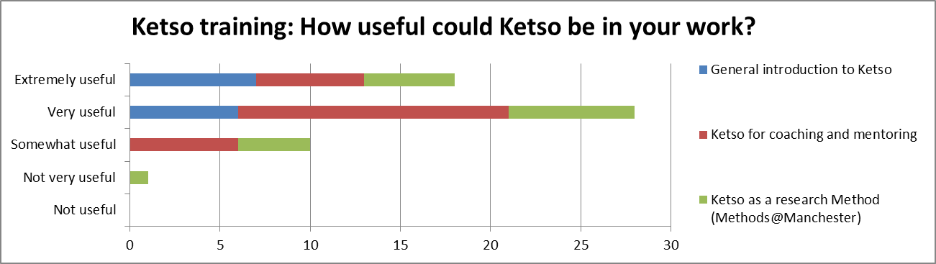
These graphs clearly show that for those who responded, there was an overwhelming impression that Ketso could be ‘very’ or ‘extremely’ useful in their work.
Participants were also asked to provide more detailed comments. The comments were assigned a colour (by the authors of this report) based on whether they were ‘positive’, ‘neutral’, ‘negative’, or ‘suggestions for improvement’. The following charts show an overview of the types of results. The first chart shows the overall distribution of the types of comments (n = 211).
Figure 6 Summary of types of feedback about Ketso training (from comments)

As can be seen, the vast majority of the comments were positive. Examples of feedback from staff participants in training were:
- I could immediately think of application for Ketso in my own work
- It helps engage all members of a class, promotes dialogue and ensures a plurality of perspectives and opinions
- Will use individual Ketso coaching in my work
- I anticipate doing consultations with high level decision makers and technocrats and may use Ketso as a tool to facilitate the process of ensuring everyone's voice is heard
- 4/5 I think it is a great way to see everyone's perspectives, stimulate discussion and ideas, great versatility of uses. Fun and effective way to engage a group and learn
- I am using it in lots of areas, and have designed whole project planning days with this supporting tool
- Already useful for own personal planning
- I'd love to use it to engage students in how to use the Atrium. I've wanted to run the workshop and now I have an excellent structure for it.
- It has the potential to easily manage group dynamics, especially domineering and passive personalities
- Great idea for using in workshops and planning meetings, team away days
- The science behind Ketso is excellent. I have enjoyed using it and exploring the principles from different areas
Suggestions for improvement included:
- More time to think and talk about introduction and naming branches etc
- Potentially could be more specific to people's job roles but I understand this is difficult!
- More focus on the strategy of building a workshop, what data is produced at what stage, how that data could be used, perhaps backed up by examples that we could follow through from initial questions to spreadsheet.
- More time to see how action plans can be made and how to analyse the data. This seems an important step in turning the Ketso into something...
- It could be done in a shorter time
- 1 day workshop and more on theory. I would attend a 'Training the Trainer' session again
- It would be better as a full day workshop as particularly more time to plan and get feedback on our own Ketso workshop ideas... just more time in general...
- I think this learning tool has scope to be taken online in line with advances in new technology but I really like the tactile side of it for Kinaesthetic learners

Feedback from students at The University of Manchester who attended workshops using Ketso
The following workshops were designed and trialled as part of this project:
- UG1 Induction 3 Workshops - Geography - led by Joanne Tippett, SEED
- UG1 Induction Workshop - Planning & Environmental Management - led by Joanne Tippett, SEED
- UG 1 North Campus Students, Feedback on Welcome Week - Student Communications Team, led by Joanne Tippett, SEED
- UG2 Sociology - Globalisation Tutorials - led by GTA SOSS
- UG 2 Law - Gender & Sexuality Course Review - led by Neil Cobb, School of Law
- Mixed years, mixed courses- Feedback on University College Sport Module - Sports and SOSS, led by Joanne Tippett, SEED
- UG 2 Gateways Mentors Feedback - Widening Participation - led by Fraser How, Ketso
- WP School Pupils Gateways Mentoring - Widening Participation - led by UG2 Gateways Mentors
- PGR SEED PhD Methods Review - led by Joanne Tippett, SEED
All of the 291 students who attended the workshops were asked to fill in one-page feedback forms on their experience. 280 feedback forms were received, and were been entered into a spreadsheet for analysis (return rate = 96%).
The following chart shows a summary of the responses to the question: ‘How did you find the use of Ketso’, which students rated using a Likert scale.
Figure 7 Student feedback on use of Ketso (all workshops)

This feedback shows that over half of the students found that the workshops were ‘very’ or ‘extremely’ useful, with very few finding it ‘not very’ or ‘not useful’.
When looking at the detailed breakdown of the feedback by workshop, it became clear that two workshops in particular had ‘worse’ feedback than the others. Both of these workshops started over half an hour late due to overrun of the larger induction programme into which they fitted, and therefore had less than half of the time planned for the workshop. The relative proportion of the feedback with these two workshops removed is instructive, and is shown below.
Figure 8 Student feedback on use of Ketso (workshops without late starts)

As can be seen, this feedback, which is gathered from sessions more representative of a ‘normal’ workshop (of 1 – 2 hours length) shows a considerably higher proportion of students finding the workshops ‘extremely’ or ‘very’ useful.
Approximately 1000 items of feedback (e.g. specific comments written in freeform as opposed to tick box form on the feedback forms) have been collected and analysed to date on the DSE project (the final report will contain the feedback from several further workshops).
These have been analysed and grouped into 3 sections: overall evaluation (comments about the value (or not!) of the whole experience), specific comments about the Ketso toolkit and the workshop process (these go into some detail about the physical nature of the kit and the workshop process that it allows), and the perceived benefits of Ketso (comments about benefits that were derived from using Ketso were categorised and coded according to different types of benefit).
The simplest level of analysis looks at whether these comments were positive, negative, or suggestions for improvement (categories assigned by the authors of this report from the feedback written on the forms).
The feedback was 79% Positive, 15% Suggestions and 6% Negative. The following chart shows an overview of the feedback, broken down into these broad sections.
Figure 9 Summary of types of feedback about Ketso from students (from comments)

Next, each of the three main sections (overall evaluation, Ketso toolkit and the workshop process and benefits of Ketso) is looked at in more detail.

Overall evaluation of experience
The following chart shows a summary of the comments that reflected the overall experience, coded as broadly paired opposites of positive and negative categories.
Figure 10 Summary of comments about overall experience

As can be seen the comments were largely positive, with the highest number of negative comments (but still very much outweighed by positive comments) being around whether the experience was ‘easy’ or ‘confusing’.
The ‘general’ category was for comments such as ‘this was good’. After this most general level, most comments were around the broad categories of whether the experience was ‘helpful’, ‘informative’, ‘easy to use’ and ‘enjoyable’.
Within this section there were also a few suggestions for improvement, the most significant by far being about reconsidering when the workshops were held (this was for the workshops that were asking for feedback, and the general suggestion was that they should be closer in time to the events (such as welcome week) for which the feedback was being gathered).
Ketso toolkit and the workshop process
The items of feedback were directly about elements of the Ketso toolkit or the workshop process (e.g. starting with a question focused on positive aspects, asking groups to swap tables to review another group’s work, asking students to make comments on the each other’s’ ideas). They represent approximately 20% of the feedback received. The following chart shows an overview of the types of comments received.
Figure 11 Summary of comments about Ketso kit and workshop process

There were a good deal of suggestions for improvement, and more negative comments about the workshop process than the toolkit itself. All of these are useful data for improving the workshop designs for future use.
For the toolkit, the qualities most commented upon favourably were: the fact that it is visual, hands-on, unique/unusual (as well as generally positive comments like ‘great kit’). The remainder of comments often represented contradictory points of view from different students (e.g. “don’t use the bell” vs “get a bigger bell”, or “love the leaves” vs “don’t like the Velcro on the leaves”).
This theme continues when considering the comments on the workshop process. By far the single most commented on aspect was the length of the workshop – with 13 people saying they were too long, but 19 saying they were too short. This somewhat polarised view is a common theme in Ketso workshops, but the relatively low number of comments on this aspect out of the total number of comments should be noted. There were also 9 comments to the effect that there should be more people invited to the workshop to have bigger groups.
The bulk of the remaining ideas were constructive suggestions on how to improve the workshop such as “Maybe solve every grey leaf and have more of a summary at the end”, “Try and make it a tad simpler” and “More quiet reflection”. It was interesting to note in the verbal feedback given in one of the first year induction workshops, that this workshop was the first time in the induction week that the students had had the time to sit down and reflect, an aspect which seemed to be generally well appreciated.
Benefits of Ketso
Approximately half of all the feedback items received spoke directly of perceived benefits of the workshop using the Ketso process. The following chart shows an overview of the ‘headline’ categories that emerged from coding this data.
Figure 12 Summary of comments about benefits of Ketso

These categories were derived from many more specific ideas, which were coded in more detail, and assigned to a headline category (as shown in the chart above). A snapshot view of the more detailed coding of these comments can be seen in the following chart.
Figure 13 Detail of codes for comments about benefits of Ketso

The two codes that had the most comments associated with them were ‘interactive’ and ‘share ideas’. These were followed by ‘value of other perspectives’ and supportive’. There are many comments related to learning from each other, creativity, fresh perspectives and inclusiveness. The second stage of analysis will further develop these codes, using data sets from workshops run by University of Manchester staff and PhDs who were trained in the first phase of the project, as well as from data collated from students taught by Joanne Tippett using Ketso in the years 2010 – 2012.
An indicative set of comments about the value of the Ketso kit follows:
- Would thoroughly like to see Ketso implemented into the courses and to be widely available for students.
- I believe it has potential to solve or illuminate problems of consensus in the field of planning.
- It helped me meet new people and really inspired me to want to start my work!
- I found the use of Ketso very useful, because it shows the context what we are dealing with clearly
- It was good to see your ideas; very visual. It also helped us to realize the similarities we all have
- It made mind mapping easier and more enjoyable
- Really smart! Easy to comment on a wide range of things without harming the environment
- Easy & good visuals to see progression of the session
- Ketso is exciting and fun!
- Phenomenal.
- Forced to think positively vs negatively about each topic
- It seems like a novel way to represent and rearrange ideas as collective, which is something I haven’t seen before.
- I could discuss concerns with other students. This gave a sense of community and that we are all in the same boat.

Conclusions and next steps
This analysis demonstrates that Ketso has proven value not only for engaging and supporting students from a widening participation background, and those with unseen disabilities, but also ‘conventional’ students. Benefits include increased learning and creativity. The induction workshops also led to an enhanced awareness of skills development and the students’ own roles and responsibilities in developing their employability.
There are now Ketso kits available for students and staff to use in the Atrium, Learning Commons and Access Summit. A key next step is to communicate about this resource, to increase awareness of the opportunities to use the kits, working in partnership with Student Communications and the Directorate of Student Experience.
Further next steps include:
- A focus group to explore emerging themes from this report and ways forward with the staff and students who identified themselves as being interested in further involvement with the project.
- Further analysis of data and writing final report for publication from this project.
- Further training and focus groups to explore options for Ketso use with Atrium, Learning Commons, Access Summit and DSO staff.
- A focus group to explore possibilities for use of Ketso with WP staff.
- Explore a trial of Ketso in Manchester Access Programme, e.g. summer school.
- Review use of Ketso for evaluating programmes – e.g. develop simpler workshop for Gateways Mentors to deliver in the next semester, and work on similar workshops for MAP pupils.
- Develop materials to support disability coaches in using Ketso in their work (in conjunction with Access Summit Coaches).
- Further develop and trial employability workshops, develop the supporting materials for others to run such workshops.
- Consider a wider roll out of the UG1 induction workshops (with refinements from the feedback received on this project). . Promote this resource to other Schools as well as SEED.
- Develop support materials, including wipe clean checklist of contents, for the Ketsos on loan.
- Review and improve feedback process for Ketso check outs in Access Summit, Learning Commons and Atrium.
- Gather feedback from students and staff using the kits for further analysis.
- Further analysis in depth of feedback and codes by type of disability, WP, international students, gender etc. (this would be enhanced by a larger data set over time)
- Consider application to HEA for support for such analysis and further research
- Write a paper/s from this experience, possible journals to include: Active Learning in Higher Education http://alh.sagepub.com; Learning Development in Higher Education http://www.aldinhe.ac.uk/ojs/index.php?journal=jldhe; Teaching in Higher Education http://www.tandfonline.com/toc/cthe20/current#.U1k5uPldWSo
- Present findings at suitable conferences – e.g. AUA, Disability Support, WP orientated conferences

Note that where data was gathered about students in order to facilitate analysis, student numbers were stored separate to feedback, which only contained information regarding disability / WP background but no personal details about the students, so they could not be identified.
A further session was offered specifically for the undergraduate tutors on the WP Gateways Mentoring Programme, but the feedback from these 10 undergraduate students is collated under feedback from students.

